
Outdoor Classroom Day
media pack

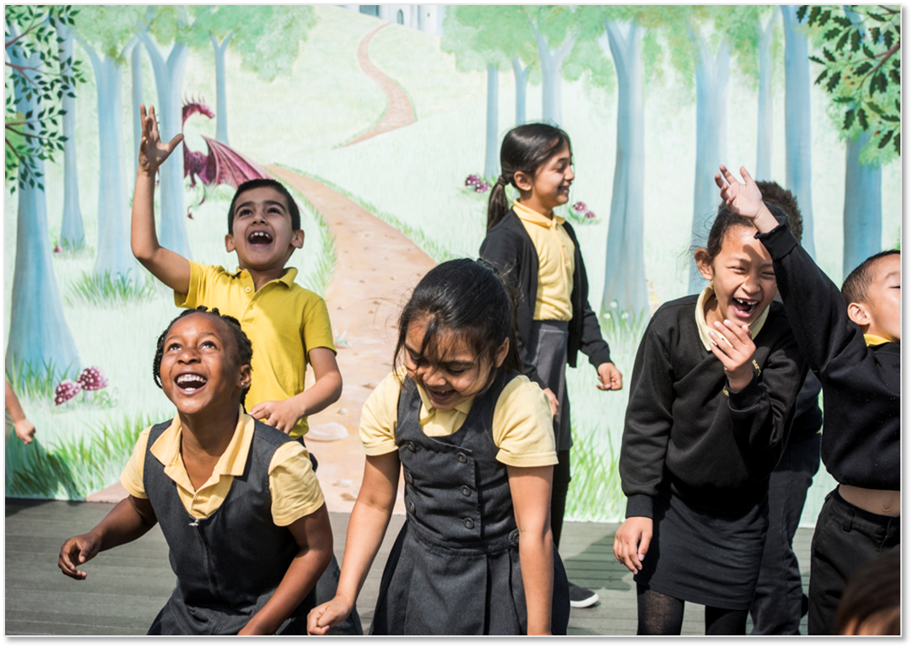

“Being outside has never been so important is it is now.”
Amanda Horton-Mastin, CEO, Semble

Contents
1. Campaign overview
2. Biographies
3. FAQs
4. Images
5. Contact details
Campaign overview
Outdoor Classroom Day is a global movement to inspire and celebrate outdoor learning and play. On the day, thousands of schools around the world take lessons outside and prioritise playtime. As well as having fun, they will show how important and easy it is to give children more time outdoors.
So that schools can participate on a day that fits with their climate and term times, the global campaign has two dates each year – check the website for future dates: www.outdoorclassroomday.com
When teachers take learning outdoors they report some powerful impacts: Children’s behaviour improves, whole classes are excited to learn, and individuals who feel inhibited by the curriculum often thrive in an outdoor environment.
When adults think back to their own happiest memories of childhood, they frequently recall the joy of playing outdoors. Play is not only central to children’s enjoyment of childhood, but teaches critical life skills such as problem-solving, teamwork and creativity.
The movement is about more than just one day; it is a catalyst to inspire more time outdoors every day, both at school and at home. To achieve this, the campaign has three aims: Outdoor learning is part of every school day for every child; Every child has great recess/playtime at school every day for at least 60 minutes, with the longer term aim of 90 minutes; Schools act as advocates for more time outdoors, so that outdoor play becomes part of every child’s everyday life.
Everyone can do something to make sure children experience the benefits of being outdoors. Parents can encourage their child’s school to get involved and take steps towards more time outdoors at home. Businesses can become campaign partners and think about how they can support local projects that support children’s play. Anyone who cares about childhood can help spread the word about the importance of outdoor play and learning.
Whatever you do, join the movement today: www.outdoorclassroomday.com
The global Outdoor Classroom Day movement is led by Semble and sponsored globally by Unilever’s Dirt For Good brands Persil/OMO.
Biographies
Amanda Horton-Mastin, CEO, Semble


Amanda is committed to harnessing the power of creativity and storytelling to drive social impact and she loves working with companies who have a social purpose and are prepared walk the talk. After starting her career in marketing at Procter & Gamble, she gravitated into the Third Sector and redirected her energies into driving social change. After 20+ years at Comic Relief running the big TV fundraising and movement building campaigns and setting up Red Nose Day in the USA, she moved to Semble and became CEO in January 2020.
Semble’s own purpose is to build positive change from the grassroots up and the team have ten years’ experience of creating and delivering campaigns to help companies activate their purpose, such as the Outdoor Classroom Day and Backyard nature campaigns. In addition, the organisation has thousands of community groups on its platform who they seek to support and strengthen. She is in awe of the work done by these small, often under-the-radar, organisations who are built into the fabric of their local communities and help provide support, connection and hope - especially in these turbulent times.
Add your headteacher’s biography here.

FAQs
How did Outdoor Classroom Day start?
In 2011, at the launch of Tim Gill’s Sowing the Seeds report, a group of educators and environmentalists discussed how schools in particular could address the issues that stop children getting outdoors. Their solution was a new campaign they called Empty Classroom Day.
In 2012 a handful of schools in London, England, got involved. By 2015, over 600 schools in 15 countries were involved. As the campaign grew, the volunteers who were running it recognised the need for dedicated investment. So, in 2016, Semble partnered with Unilever’s Dirt is Good team to grow the movement and take it global.
Following consultation with school leaders, play experts and NGOs around the world, the global campaign became Outdoor Classroom Day. There are currently dedicated campaigns running in 13 countries, in addition to a much wider network of schools getting involved in more than 110 countries worldwide!
The campaign’s founder and advisory board member, Anna Portch, continues to be involved in every campaign day.
Who is behind Outdoor Classroom Day?
The global Outdoor Classroom Day movement is led by Semble and sponsored globally by Unilever’s Dirt For Good brands Persil/OMO. Semble connects and resources grassroots community projects and is a founding partner of the original campaign. Dirt For Good aims to support teachers, parents and carers to empower children to do good for the planet, through simple and engaging activities.
Semble works with respected environmental and educational NGOs around the world to deliver locally relevant campaigns, from Finland to Brazil. Many of these NGOs are supported by local Dirt is Good teams, and the experts they work with, to broaden their reach. But really the campaign is delivered on the ground by teachers, parents and supporters! None of us can do this alone.
Is Outdoor Classroom Day just one day?
Outdoor Classroom Day is about more than just one day, it’s a global movement to inspire and celebrate outdoor learning and play every day. By getting involved in the annual celebrations, teachers help send a message to the world that time outdoors every day is important for every child. They also help to achieve these longer-term shared goals:
- Outdoor learning is part of every school day for every child.
- Every child has great recess/playtime at school every day for at least 60 minutes, with the longer-term aim of 90 minutes.
- Schools act as advocates for more time outdoors, so that outdoor play becomes part of every child’s everyday life.
What are the benefits for taking children outdoors to play and learn?
When teachers take learning outdoors they report some powerful impacts: Children’s behaviour improves, whole classes are excited to learn, and individuals who feel inhibited by the curriculum often thrive in an outdoor environment.
When adults think back to their own happiest memories of childhood, they frequently recall the joy of playing outdoors. Play is not only central to children’s enjoyment of childhood, but teaches critical life skills such as problem-solving, teamwork and creativity.
Find out more about the benefits of outdoor play and learning and the difference that Outdoor Classroom Day is making in schools around the world in the Muddy Hands and Playtime Matters reports.
Does the Government back outdoor lessons?
In countries including Australia, Canada and the UK, most state or regional governments formally recognise outdoor learning and break time as beneficial. But children are still by no means learning outdoors every day or playing outdoors; either for the minimum hour recommended for physical activity, or for the 25% of school time that some psychological research on mental wellbeing suggests is optimal.
Is it free for teachers to get involved?
Yes! Registration is free and there is even a whole library of free resources such as outdoor lesson plans for teachers to access on the Outdoor Classroom Day website.
What do teachers get when they sign up?
Teachers get to put their school on the Outdoor Classroom Day map and become part of the global movement for more time outdoors every day. If they opt in, they receive regular campaign emails with resources, inspiration and information to help them get outdoors on the day and all year round.
How can non-teachers get involved?
They can spend some time outdoors on the day and share their experiences on social media using #OutdoorClassroomDay!
Nurseries, kindergartens, after-school groups, play organisations youth groups, and even universities can sign up in the ‘other’ box.
Parents of school-aged children can use the ‘letter to parents’ on the website to ask their child’s school to sign up. They could take their children outside after school on the day as well and sign up choosing the ‘Parent/Carer’ option.
Individuals who work for organisations that believe in the power of outdoor learning and play can get involved by helping to spread the word about the campaign. The ‘supporter pack’ on the campaign website provides ideas and resources.
Contact
For further information and to arrange an interview with a spokesperson, please contact ADD MEDIA LEAD NAME AND CONTACT DETAILS HERE. To arrange an interview with Amanda Horton-Mastin, please contact Claire Colvine on claire@outdoorclassroomday.com.

